Espresso coffee machine
Instruction manual

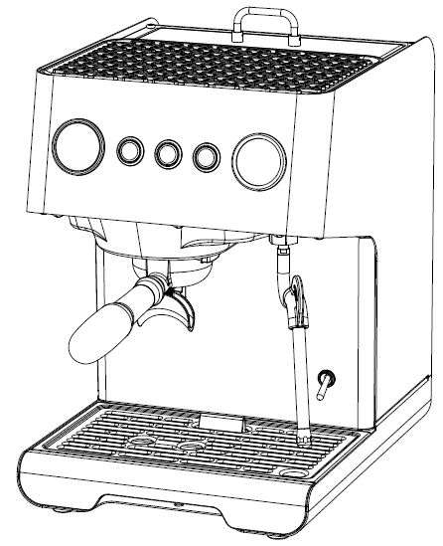

Item | AVX DB1 PRO
Voltage | 220-240V 50Hz/60Hz
Power | 2550W-3050W
Water tank | 1.7L
Pressure | 15 Bar

IMPORTANT SAFEGUARDS

Before using machine always read carefully and comply with all these instructions. We cannot accept any responsibility for the consequences of improper use.
1.Check voltage to be sure that the voltage indicated on the name plate agrees with your voltage.
2.This appliance has been incorporated with a grounded plug. Please ensure the wall outlet in your house is well earthed.
3.Close supervision is necessary when the appliance is used by people. Place the machine out of the reach of children and persons with limited capabilities.
4.Do not place on or near a hot gas or electric burner or in a heated oven.
5.Unplug from outlet when not in use and before cleaning. Allow to cool before putting or taking off parts, and before cleaning the appliance.
6.Do not operate any appliance with a damaged cord or plug or after the appliance malfunctions, or has been damaged in any manner. Return appliance to the nearest authorized service facility for examination, repair or adjustment.
7.The use of accessory attachment not recommended by the appliance manufacturer may result in fire, electric shock, or injury to persons.
8.The appliance should be placed on table or flat place .Do not place the machine on the edge of desk or table.
9.Do not let the power cord contact with hot parts of machine.
10.Some parts will be heated to very high temperature when working, example steaming nozzle, funnel holder. Do not touch any hot parts. Use the handle of the funnel.
11.To protect against fire, electric shock and injury to persons, do not immerse cord, plugs, or body of machine in water or other liquid.
12.It must be protected against freezing conditions, because the residual water of boiler and pump will become ice and damage machine.
13.Once the fault, defect or machine drop caused by suspicious defect, unplug the power plug immediately, do not operate on the problem machine.
14.Do not use outdoors.
15.SAVE THESE INSTRUCTIONS FOR FUTURE USE.
- Machine use condition:
- Voltage: AC220V~50Hz
- Water: Pure water or distilled water cannot be used. please use softened water,suggest to install softened water equipment.
- Room temperature: 0-55°C
* KNOW YOUR MACHINE
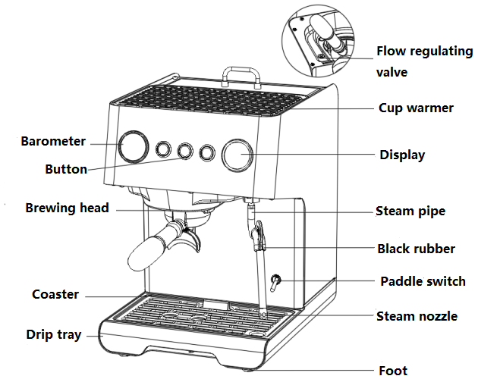

Product size：W265* H376 * D335 mm

* OPERATION FUNCTION
Button | Name | Function
 | Automatic coffee button | Press this button to make coffee and press it again to stop
 | Manual coffee button | Press this button to make coffee and press it again to stop
 | Steam button | Press this button to make steam and press it again to stop
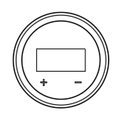 | Setting panel | - Press "+" button 3s to enter temperature setting function, the "C" value will flash, press the "+" button, the value will increase; press the "-" button, it will decrease; after setting the value for 3 seconds, the system will automatically save the value.  2. Press "-" key 3s to enter coffee pre-infusion time setting function, the "P" value will flash, press the "+" key, the value will increase; press the "-" key, it will decrease,after setting the value for 3 seconds, the system will automatically save the value.

* PRODUCT PARAMETER
Model No. | AVX DB1 PRO
Specification | 220-240V 50Hz/60Hz 2550W-3050W
Water | Pure water or distilled water cannot be used. please use softened water
Water tank | 1.7L detachable water tank
Coffee boiler | 220V 50Hz 1000W , (SUS304), 0.55L
Steam boiler | 220V 50Hz 1460W,(Cast aluminum)
Pump | Two EP5 ULKA pump, 15bar
Barometer | 20Bar
Operation panel | 3 buttons+1 LCD touch screen
* ACCESSORIES
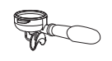  Double cup porta filter holder | 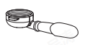  Single cup porta filter holder | 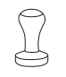  Tamper | 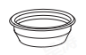  Filter
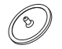  Cleaning pin | 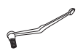  Brush | 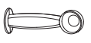  Coffee spoon

* FOR THE FIRST USE
- Move the coffee machine from the package, and check the accessories according to the list;
- Clean all the detachable components;
- Insert the power plug into the switch socket with grounding protection.

* TURN ON MACHINE
- Open the lid, take out water tank, and pour appropriate water into tank. Do not exceed the MAX capacity; Put back the water tank and close the lid;
- Connect the power supply, the buzzer sounds for 0.5s and all the buttons will light on, display show "888" for 2s;
- Turn on power switch,display will show the coffee temperature and all buttons will light on, after machine pump water after 8s, it start preheating and button indicator lamp will flash, after finishing preheating, the indicator lamp keep lights on;
- For first time use, machine takes about 5min to finish the preheating.
Note: Even preheating is not finished, you also can use the coffee machine directly, but the temperature of the coffee or hot water will too low. Steam and coffee can be opened or closed independently.

* MAKING COFFEE
1. Note: Coffee powder that is too fine can easily block the filter.
2. Too much coffee powder will easily cause the portafilter holder not be screwed tightly, and coffee will leak from the side of the portafilter.
3. Please do not touch the pot body part to avoid scalding.
* AUTOMATIC MAKING COFFEE
1. Put the coffee powder into porta filter holder and press it tight;
2. Put the porta filter holder into the machine, and rotate right to lock the filter holder;
3. Put the cup under porta filter mouth;
4. Press the automatic coffee button to make delicious coffee, the display show the counting time and automatically exits after 25s (default pre-infusion time is 2s), then machine will return to standby mode;
Note:During making coffee, you can turn off the coffee button at any time to exit.
5. Rotate left to remove filter holder after finished, knock out coffee grounds, clean the filter and filter holder for next use.

* MANUAL MAKING COFFEE
1. Put the coffee powder into porta filter holder and press it tight;
2. Put the porta filter holder into the machine, and rotate right to lock the filter holder;
3. Put the cup under porta filter mouth;
4. Press the manual coffee button to make delicious coffee, the display show the counting time and automatically exits after 120s (no pre-infusion), then machine will return to standby mode;
Note:During making coffee, you can turn off the coffee button at any time to exit.
5. Rotate left to remove filter holder after finished, knock out coffee grounds, clean the filter and filter holder for next use.

* MAKING STEAM
1. When machine finished pre-heating, press steam button to make steam,display will counting time;
2. During making steam, you can turn off the steam button at any time to exit(Do not making steam exceed 5min).
Note: Caution high temperature of steam pipe when in use, do not touch to avoid scald. Please hold the black rubber part to move the steam pipe.

* SETTING
Setting automatic brewing time:
1. When machine under standby mode, long press automatic coffee button 3s to enter setting mode, the value will flash.
2. Press "+" to increase the value; press "-" to decrease the value.
3. After setting the value for 3s, machine will automatically save the value, setting is finished.(Default time:25s, Setting range: 10s-120s).

Setting coffee temperature:
1. When machine under standby mode, long press "+" 3s to enter setting mode, the "C"value will flash.
2. Press "+" to increase the value; press "-" to decrease the value.
3. After setting the value for 3s, machine will automatically save the value, setting is finished.(Default:93℃, Setting range: 80℃-110℃).

Setting pre-infusion time:
1. When machine under standby mode, long press "-" button 3s to enter setting mode, the "P"value will flash.
2. Press "+" to increase the value; press "-" to decrease the value.
3. After setting the value for 3s, machine will automatically save the value, setting is finished.(Default time:2s, Setting range: 0s-30s).

Flow regulation:
Turn the flow regulating valve with a flat screwdriver to adjust the flow rate.

Restore Default Setting:
When machine under standby mode, press automatic coffee button and manual coffee button at the same time for 3s, display screen flashing "888" 5times and machine will restore default setting.

ECO mode:
Machine will enter ECO mode without any operation for about 28min, display screen will show ECO, press any button to wake it up(will not enter ECO mode if under steam standby mode).
* TURN OFF MACHINE
- At any time,turn off the power button to turn off the machine;
- Please turn off external power supply when you don’t use the machine.

* DESCALING
Note:When making coffee and steam for 500 times,machine will enter descaling reminder mode: display screen will show "CLn". It will automatically exits the descaling reminder mode and counting time again until you finished the descaling operation of the steam pipe (can make coffee and steam even under descaling reminder mode).
- Pour water and descaler into the water tank to the "Max" level (about 1.7L, ratio is 4:1, details please follow the instruction of descaler. Please use “household descaler”or you can use the citric acid replace descaler.(water and citric acid ratio is 100:3)
- Steam part descaling: Press steam button 3S to enter steam descaling mode,steam button indicator light keep lights on,other buttons and CLn flashing, The steam pipe produces hot water or a large amount of steam, machine will automatically exitsthis mode after 60s (you can press steam button again to exit during this process).
- Coffee part descaling:Put cleaning pin and descaler to filter and inserted it into brewing head, press manual button 3s to enter descaling mode, manual coffee button indicator light keep lights on,other buttons and CLn flashing, water come out 8s and stop 4s until lasts for 60s to exist this mode(you can press manual coffee button again to exit during this process), remove the cleaning pin and press manual coffee button again, let water come out for 120s.
- Coffee boiler descaling:Press automatic coffee button and let water come out 5-10times, allow descaler stay in boiler over than 15min, then press manual coffee button to let water come out 120s.
- Pour water into the water tank again (without descaler), press steam button 3S to enter descaling mode, press automatic coffee button to operate 5-10 timesuntil there is no water. (If it is not cleaned enough, repeat above steps many times).

* CLEANING & MAINTENANCE
1. Disconnect the power before cleaning and let the coffee machine fully cool down.
2. Use a cloth or neutral detergent to clean the outer surface of the coffee machine.
3. Rotate to remove the filter and holder, knock out the coffee grounds inside, then clean it.

* CLEAN MINERAL DEPOSITS
1. After the coffee machine is used for a long time, need clean internal water channels, the coffee machine needs to be descaled and maintained every 2 months of use.
2. Follow the operation of "DESCALING " to clean the machine.

*ANTIFREEZE STEPS
Note: if the temperature of the coffee machine is lower than the freezing point, it will cause damage to the equipment, In order to prevent the coffee machine from freezing and cracking during transportation or storage, the following steps must be followed before the coffee machine is shut down:
- When the coffee machine needs to be shut down after use, pour out all the water in water tank;
- Put back the water tank to original position and disalay show F3, long press manual coffee button 5s to let water come out;
- Press manual coffee button again to close until there is no water come out from the coffee boiler.
- Turn off the coffee power after following the above steps;
- Before using the coffee machine next time, install the water tank and operate normally.



*TROUBLE SHOOTING
Problem | Cause/Result | Solution
No water comes out | Water tank is empty | Pour water into water tank
No water comes out | The input voltage or  frequency is inconsistent  with nameplate | Make sure the voltage and  frequency is consistent with  the nameplate
No water comes out | Machine malfunctions | Please contact with the  authorized service
No steam comes out | Steam nozzle is clogged | Clean steam nozzle
No steam comes out | Water tank is empty | Pour water in water tank
No steam comes out | Machine malfunctions | Please contact with the  authorized service
Coffee overflow from the edge of funnel seal ring | Too much coffee powder in filter | Clean the filter, then pour  appropriate coffee powder
Coffee overflow from the edge of funnel seal ring | Coffee powder remained in the seal under group head | Clean the seal under group head
Coffee overflow from the edge of funnel seal ring | Implementation of the above operation problems still exist | Please contact with the  authorized service
Coffee comes out too slow or no coffee comes out | coffee powder is too fine, and clogged filter | Use thicker coffee powder after cleanning the filter
Coffee comes out too slow or no coffee comes out | Filter holes are blocked | Clean the filter with brush or pin
Coffee comes out too slow or no coffee comes out | Water tank is not inserted | Insert the water tank in place
Water leakage on the bottom of coffee machine | Drip tray is filled up | Please clean the drip tray
Water leakage on the bottom of coffee machine | Joint leakage | Change the joint or sealing
Water leakage on the bottom of coffee machine | Machine malfunctions | Please contact with the  authorized service
Steam can’t froth milk | Steam power button is closed | Open steam power button
Steam can’t froth milk | The container is too big or  the shape is not fit | Use high and narrow cup or garland cup
Steam can’t froth milk | Used skimmed milk | Use whole milk
Display F3 | No water in water tank or do not inserted water tank | Insert water tank and pour in appropriate water
Display E1 | NTC of coffee boiler is short circuit | Check whether room temperature lower than 0 / Please contact with the  authorized service
Display E4 | NTC of steam boiler is short circuit
Display Cln | Descaling reminding | Follow steps to do the descaling
*If you have not been able to solve the problem, contact customer support in your country.
-
*DISPOSAL
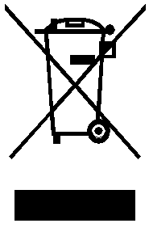
Please dispose of old machines in an environmentally neutral way.
Old machines contain valuable materials which should be salvaged for recycling. Please therefore dispose of old machines via your regional collection system.

